**Mapping Relationship Business Class & Item**

**Aviation Personal Accident(APA)**

**Risk Text Mapping**

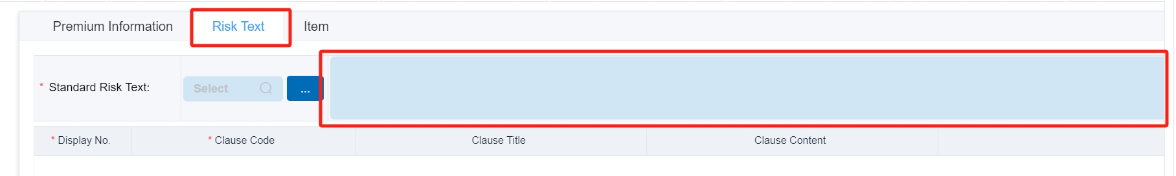

* **Open the below folder and copy the text for showing by default Risk text from the folder.**

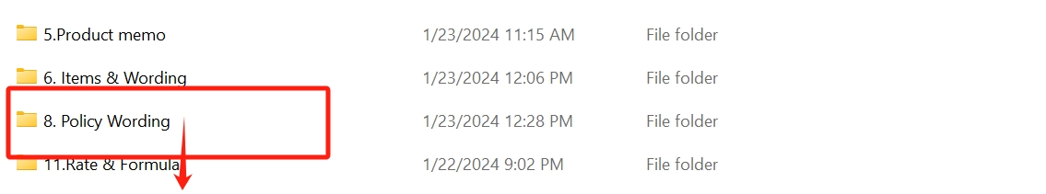

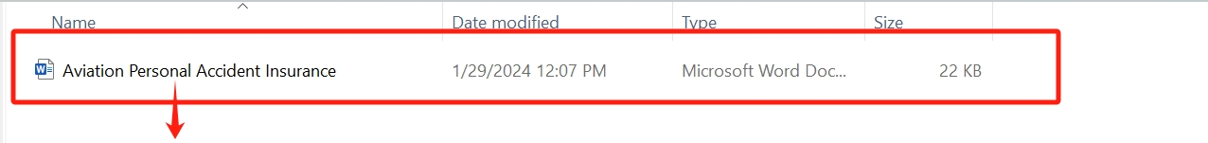

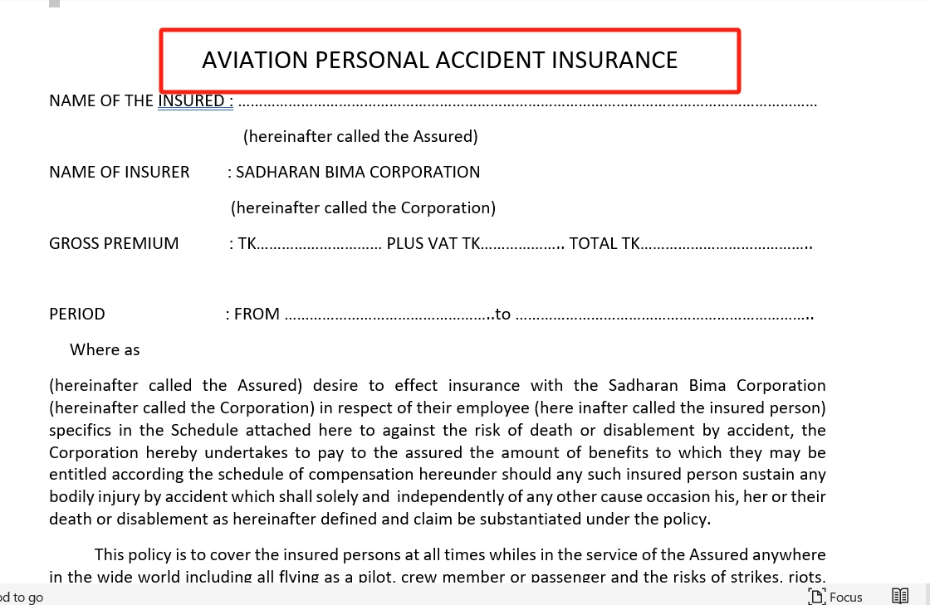

**Item Text Mapping**

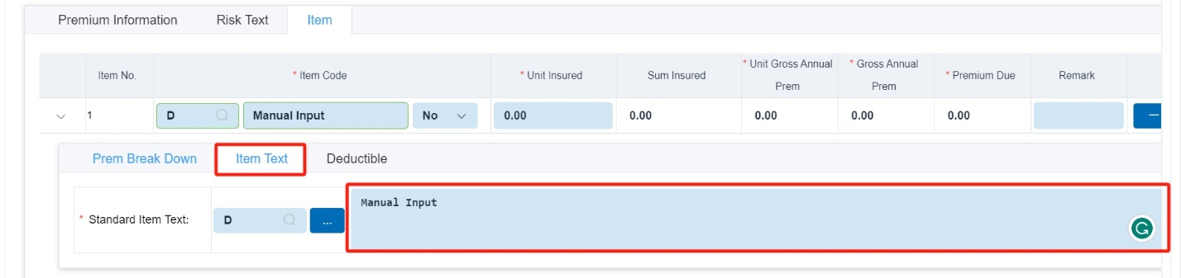

* Here Item text requires Manual Input